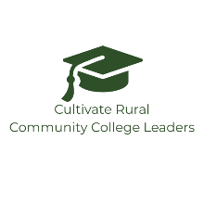
Interview Process Template

- Review the position and job description
- Develop final candidate evaluation sheet
- Determine timeline of the process and set interview times in your calendar:
  - Job Posted:
  - First Review of Applications:
  - Virtual Interviews:
  - In-person Interviews:
  - Deliberation:
  - Background Checks and Job Offer
- Invite committee members and send important dates:
  - Committee:
- First round interview questions:
  - (Category) Question:
- In-person interview questions and activity:
  - (Category) Question:

